

INGRAHAM POLYTECHNIC

Computer Science & Engineering

6th Semester

Session: 2023-24

Major Project (StudySpace)

Submitted To: Mr JN Upadhyay Sir

Submitted By :-

Shivam Kawatra

Jaanasheen Chaudhary

Acknowledgement

I would like to express my deepest gratitude to everyone who contributed to the successful completion of this project. First and foremost, I am grateful to Ingraham Polytechnic for providing me with the resources and environment necessary for undertaking this project.

My sincere appreciation goes to my project guide, Mr. JN Upadhyay Sir, for his invaluable guidance, support, and encouragement throughout the development of the StudySpace website. His insights and expertise have been instrumental in shaping this project, and his mentorship has been a source of inspiration.

I also extend my thanks to my peers and classmates for their constructive feedback and collaborative spirit, which have significantly enhanced the quality of this project. Additionally, I am grateful to my family for their unwavering support and motivation during the entire process.

Lastly, I would like to acknowledge the various online resources, tutorials, and study materials that provided essential information and guidance during the development phase. This project would not have been possible without the collective support and contributions of all these individuals and resources.

Course Management System

Introduction
A Course Management System (CMS) is an online platform designed to facilitate the management and delivery of educational content. It provides a centralized space for students and educators to access, share, and manage learning materials, assignments, and resources. CMSs aim to streamline educational processes and enhance the learning experience.

Purpose
The primary purpose of the StudySpace CMS is to offer students a free and accessible platform to access study materials, including syllabi, notes, lectures, and previous year questions (PYQs). By providing these resources at no cost, StudySpace aims to democratize education and support students in their academic pursuits.

Scope
The scope of the StudySpace project includes the development and implementation of a comprehensive course management system. This involves creating a user-friendly website where students can easily navigate and access their study materials. The CMS will include several sections:
- Syllabus: Organized course outlines and requirements.
- Notes: Categorized study notes for various subjects.
- Lectures: Access to lecture videos and supplementary materials.
- PYQs: Previous year question papers for exam preparation.

Overall, StudySpace will serve as an all-encompassing platform to manage and disseminate study material content, enhancing the educational experience for students.

Objectives of Course Management System

1. Accuracy
- Up-To-Date Study Material: The system ensures that all educational resources, including syllabi, notes, lectures, and previous year questions (PYQs), are accurate and current. Regular updates are performed to reflect the latest curriculum changes and information.

2. Efficiency
- Organized Content: Content is meticulously categorized and structured, making it easy for students to navigate and quickly access the resources they need. This systematic organization enhances the overall efficiency of the platform.

3. Customer Satisfaction
- Free Access: By providing all educational materials at no cost, the system guarantees accessibility for all students, regardless of their financial status. This commitment to free access ensures that education is available to everyone, fostering a more inclusive learning environment.

By fulfilling these objectives, the Course Management System successfully meets the needs of students, providing them with reliable, easily accessible, and free educational resources, thereby enhancing their overall learning experience.

Project Code

index.html
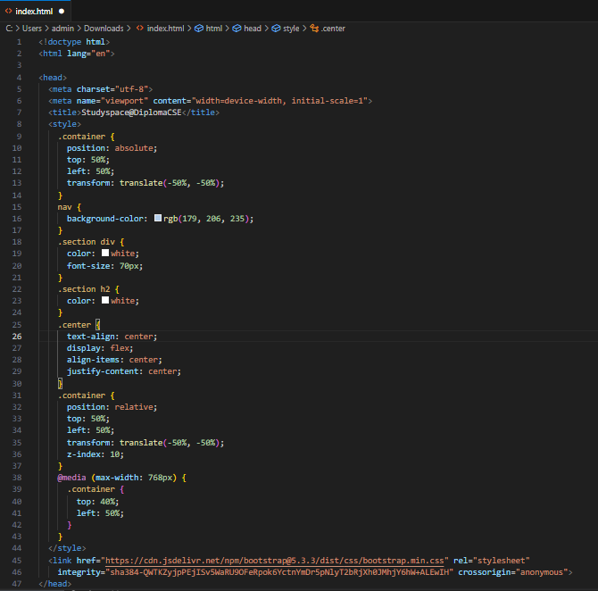
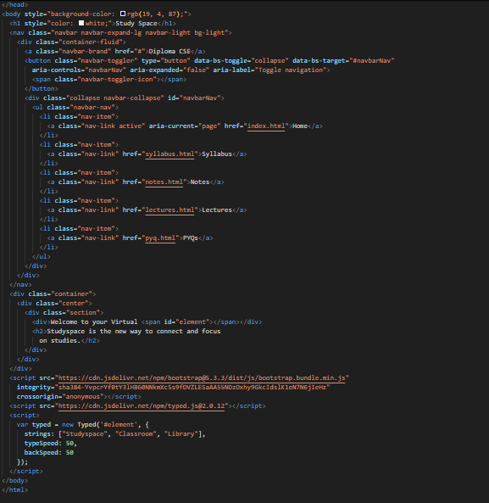

syllabus.html
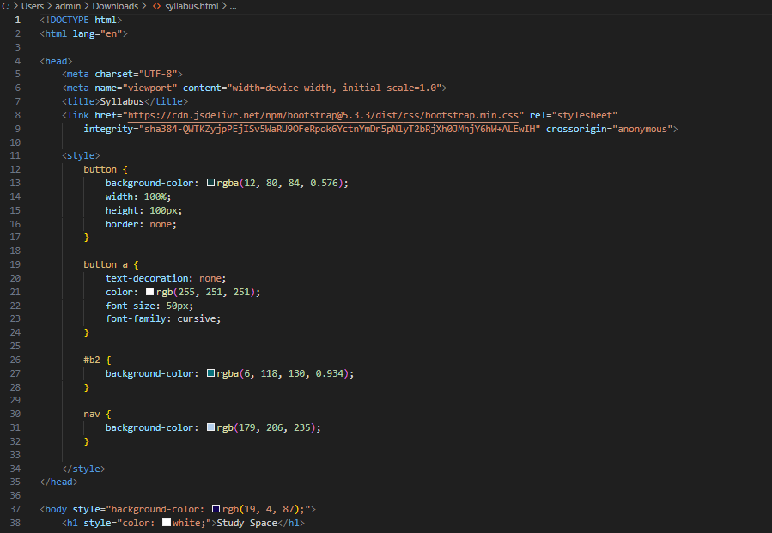
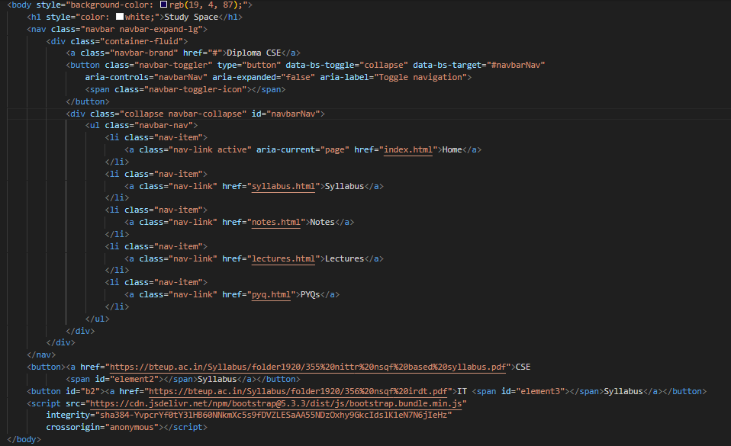

pyq.html
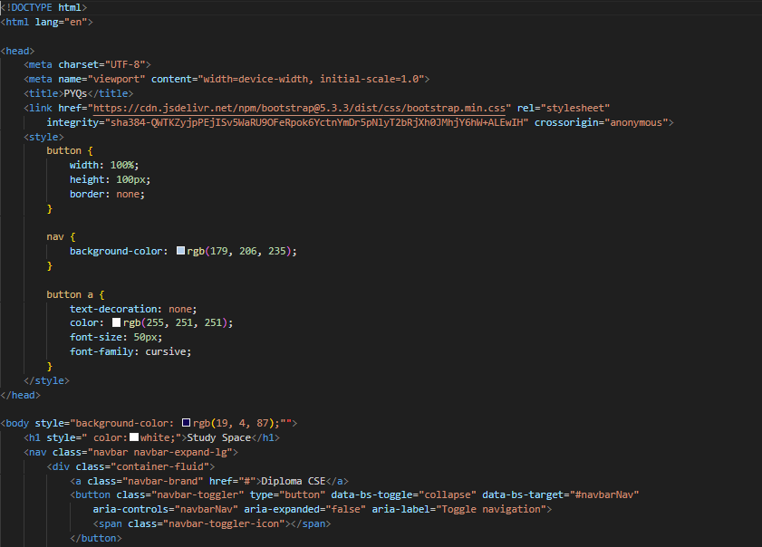
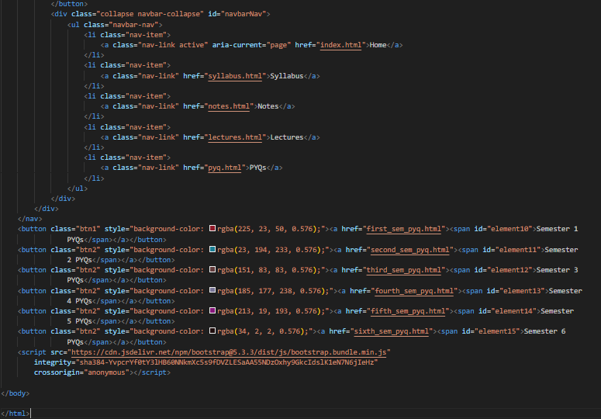
notes.html
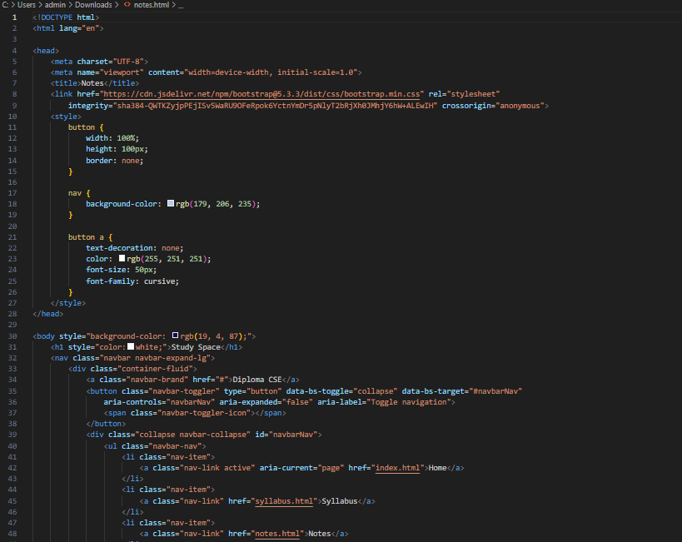
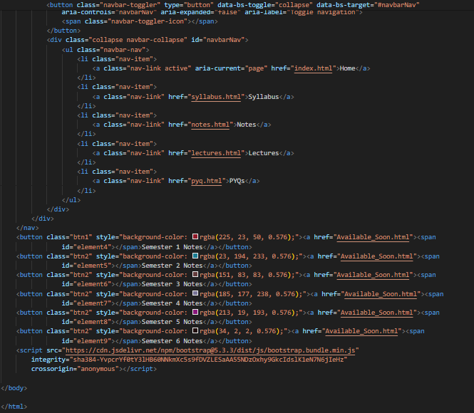
lectures.html
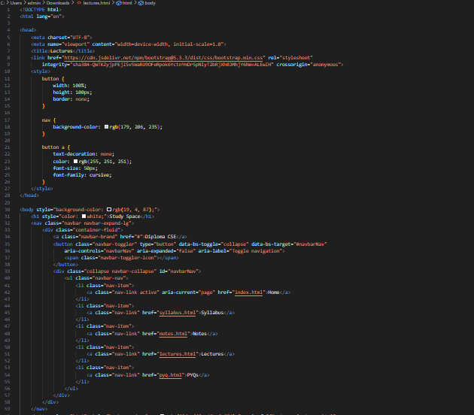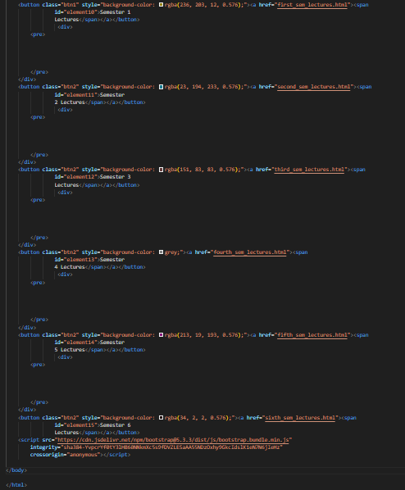
Output

Home Page:
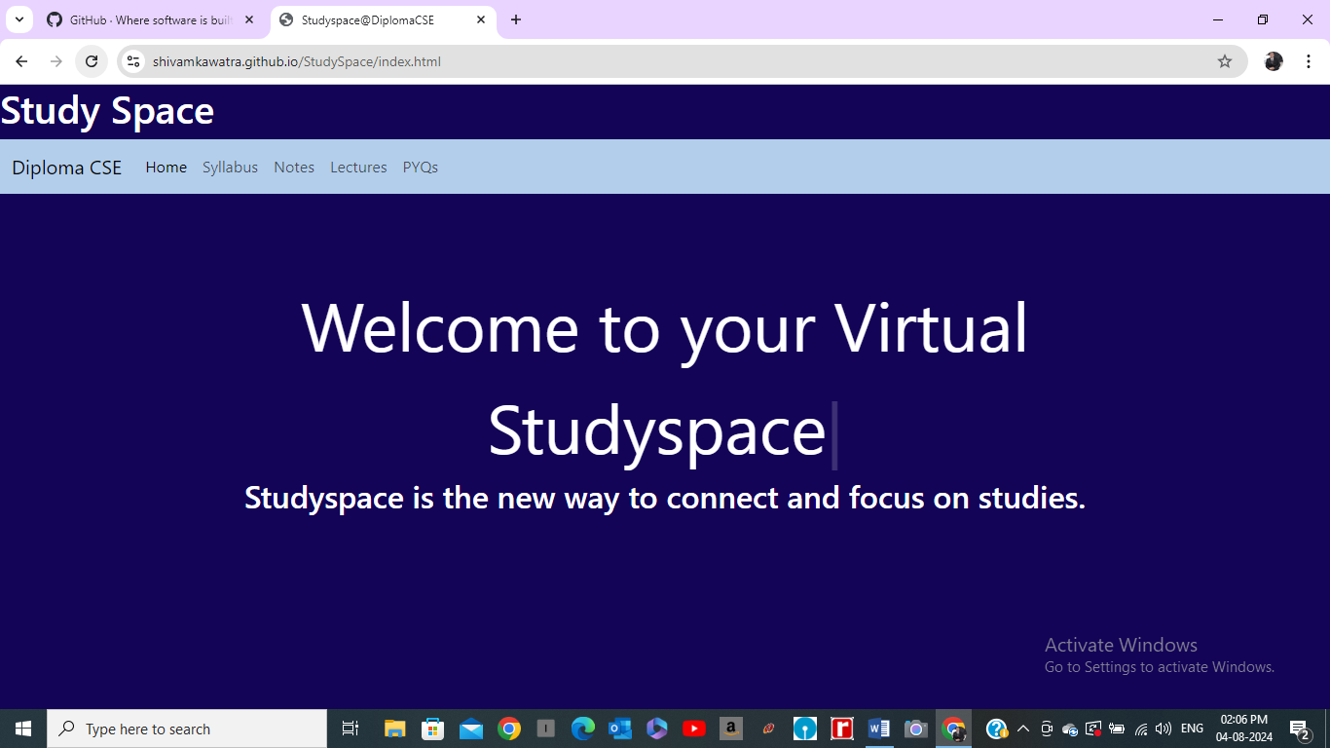

Syllabus Page:
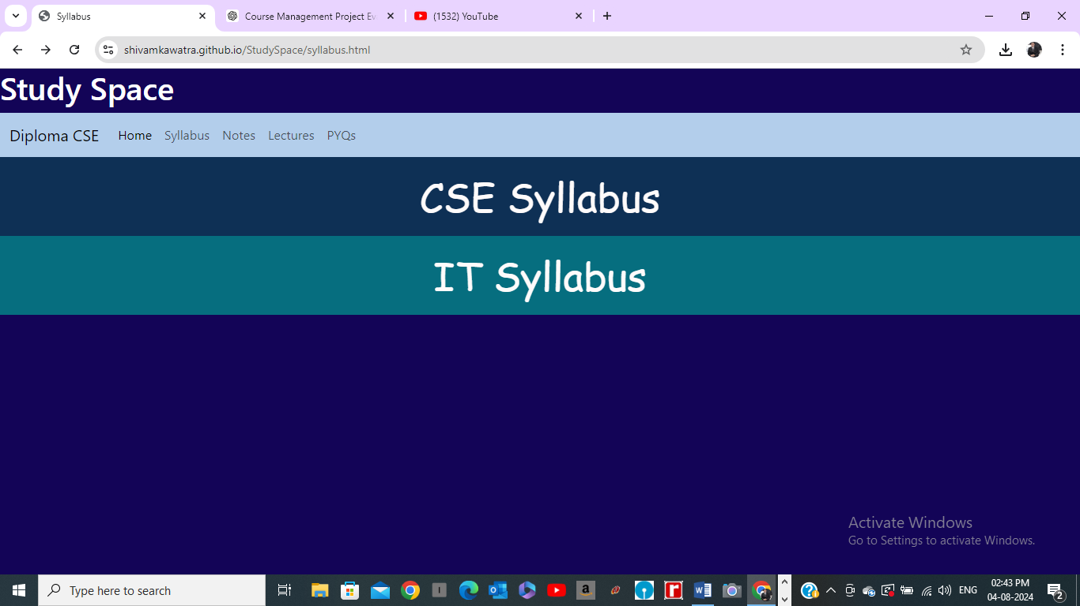

Lectures Page:
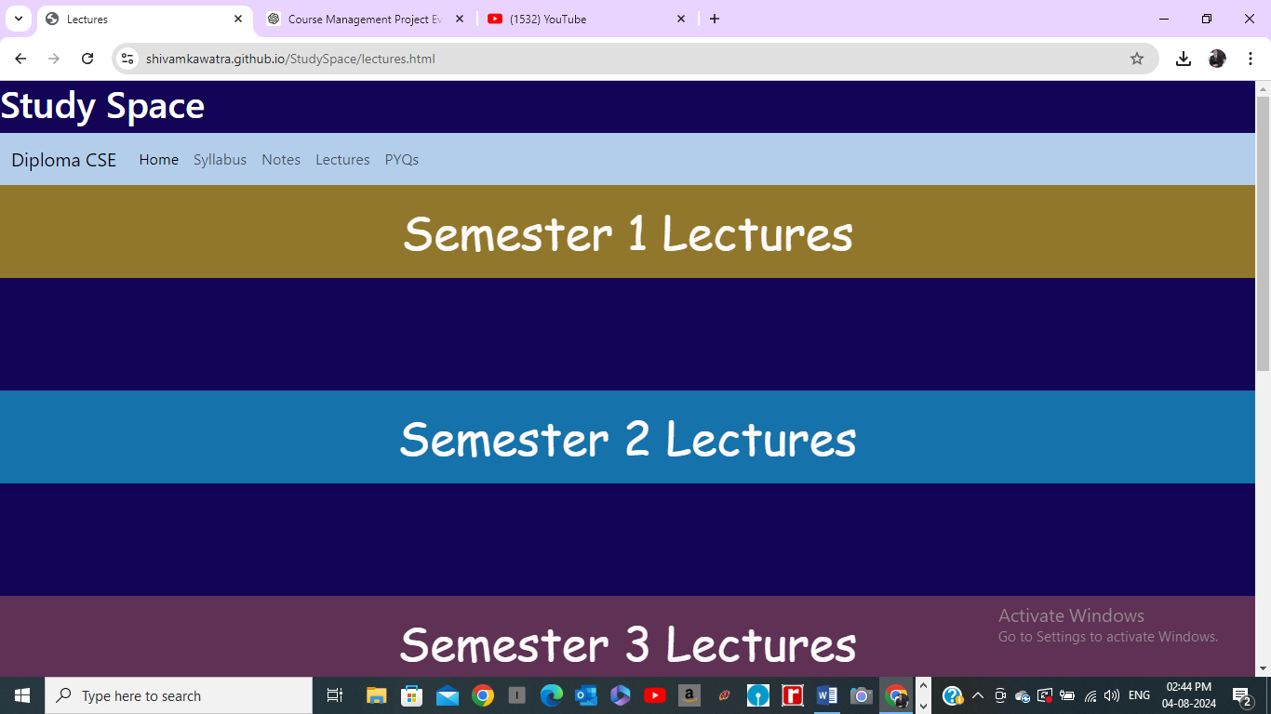

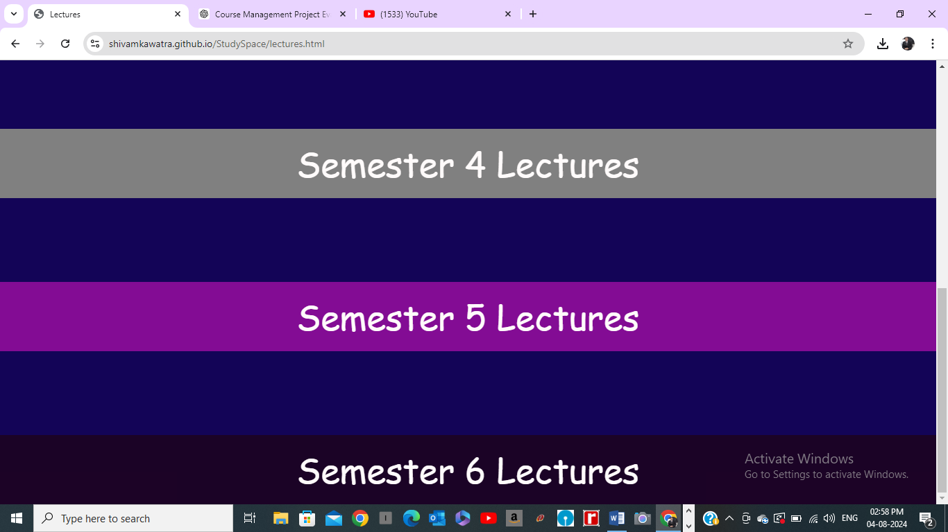

Notes Page:
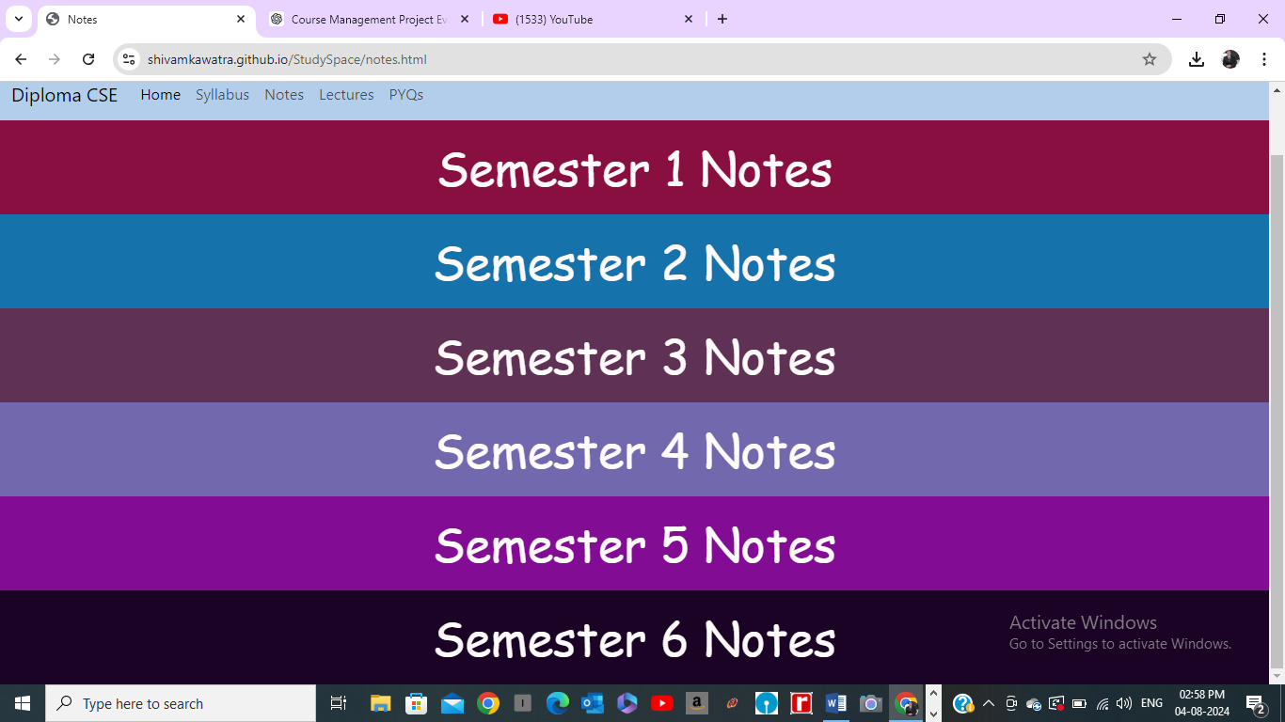

PYQs Page: 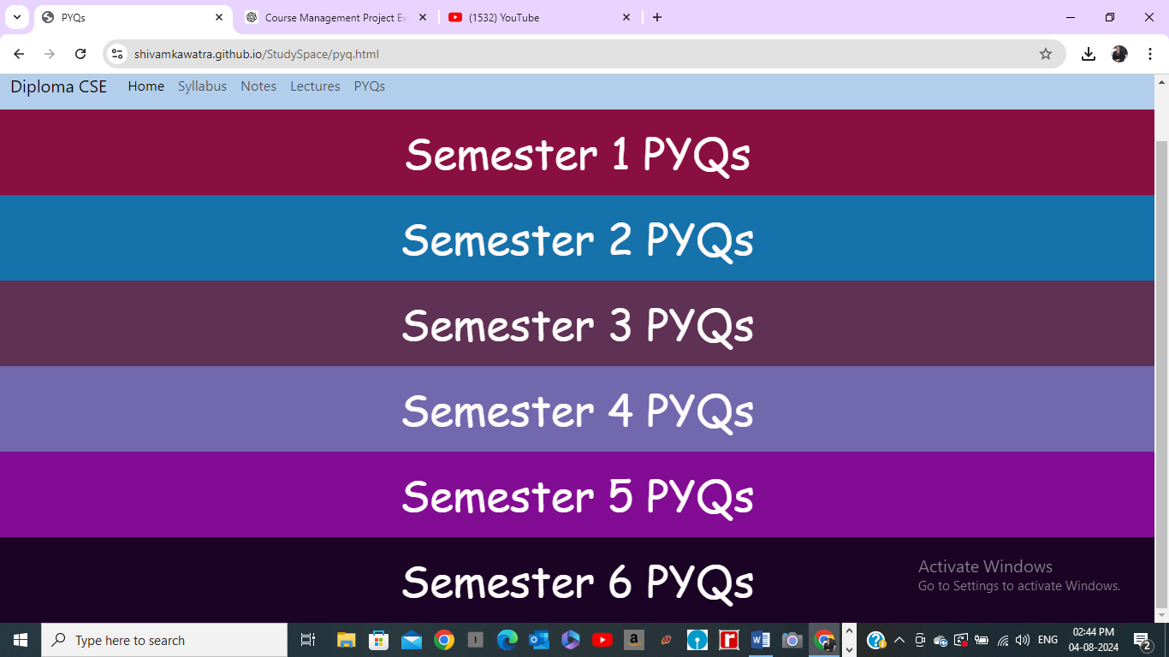

Testing

Testing for Test Cases :-

Test Case 1: Playing Lectures
- Objective: Ensure lecture videos play correctly on various devices.
- Steps:
  - Navigate to the "Lectures" section.
  - Select a lecture video.
  - Click the play button.
  - Ensure the video starts playing.
  - Test playback controls (pause, play, volume).
  - Check playback on different devices (desktop, tablet, smartphone).
- Expected Result: Lecture video plays smoothly, controls function properly, and video works on all tested devices.
- Status: Passed

Test Case 2: Downloading Notes
- Objective: Verify that notes can be downloaded without issues.
- Steps:
  - Navigate to the "Notes" section.
  - Select a subject and topic.
  - Click the download link/button for a note.
  - Confirm that the file downloads successfully.
  - Open the downloaded file to ensure it is intact and readable.
- Expected Result: Note downloads successfully and is readable.
- Status: Passed

Test Case 3: Downloading Previous Year Questions (PYQs)
- Objective: Ensure PYQs are downloadable and accessible.
- Steps:
  - Navigate to the "PYQs" section.
  - Select a subject and year.
  - Click the download link/button for a PYQ.
  - Confirm that the file downloads successfully.
  - Open the downloaded file to ensure it is intact and readable.
- Expected Result: PYQ downloads successfully and is readable.
- Status: Passed

Test Case 4: Downloading Syllabus
- Objective: Verify that syllabus documents can be downloaded correctly.
- Steps:
  - Navigate to the "Syllabus" section.
  - Select a course or subject.
  - Click the download link/button for the syllabus.
  - Confirm that the file downloads successfully.
  - Open the downloaded file to ensure it is intact and readable.
- Expected Result: Syllabus downloads successfully and is readable.
- Status: Passed

Test Case 5: Regularly Updating Content
- Objective: Ensure that content updates are reflected on the website.
- Steps:
  - Make updates to a syllabus, note, lecture, or PYQ in the backend system.
  - Navigate to the relevant section on the website.
  - Verify that the updated content is visible.
  - Ensure that old content is appropriately replaced or archived.
- Expected Result: Updated content is displayed correctly on the website, and no outdated information is shown.
- Status: Passed

Summary of Test Results
All test cases for playing lectures, downloading notes, previous year questions, and syllabi, as well as regularly updating content, have passed. This indicates that the website's functionalities are working correctly, providing a seamless and efficient user experience.
Conclusion
The development of the StudySpace website has been a remarkable achievement, addressing the crucial need for accessible and organized educational resources. By providing a centralized platform where students can easily access syllabi, notes, lectures, and previous year questions (PYQs), StudySpace has significantly enhanced the efficiency and accuracy of resource management. The platform's regular updates ensure that the information remains current and relevant, directly benefiting students' learning experiences.

Moreover, the emphasis on free access ensures that educational resources are available to all students, regardless of their financial background. This inclusivity not only democratizes education but also promotes equal opportunities for academic success. The user-friendly design and organized content structure make it easier for students to navigate and find the materials they need, thus improving their overall academic performance.

In conclusion, the StudySpace project has successfully fulfilled its objectives of accuracy, efficiency, and customer satisfaction. By leveraging digital tools to create an inclusive and effective learning environment, StudySpace stands as a testament to the potential of technology in education. The project not only meets the current needs of students but also lays a foundation for future enhancements and expansions, ensuring continued support for student learning and development.

